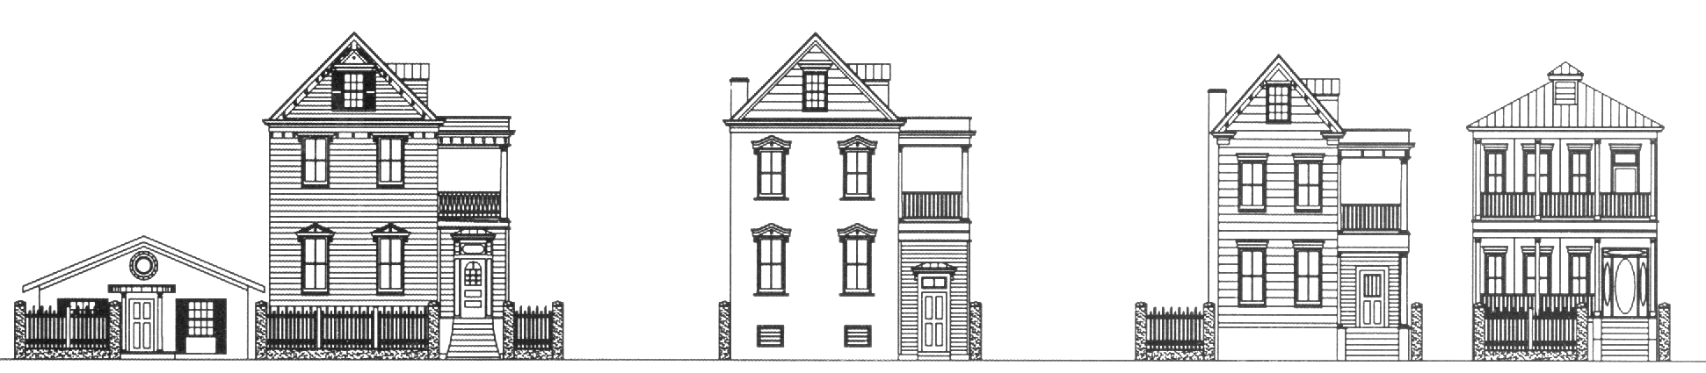
St. Philip Square, LLC • P.O. Box 1231 • Charleston, SC 29402 • (843) 577-7450

Choose either Yearly Parking Contract at $100/month or Month to Month at $150/month

Parking Space #_________________(Office Use Only)

Name______________________________________________ Apt. #____________________

Mobile #_______________________Email:_________________________________________

Make of Vehicle______________________________________ Model___________________

Color______________________ Registration #______________________________________

License Tag # ________________________________________ State____________________

Please Attach a copy of Registration

We are fortunate enough to be able to offer our tenants parking, for lease. However we do not have excess spaces available for friends, so any violation of parking or allowing friends to park in inappropriate spots can lead to you losing your privilege to park in this lot. A Boot will be installed on any vehicle violating parking privileges and a fine will be paid to remove it. Automatic towing is enforced for vehicles with no decal.

I, ______________________________ agree to rent a parking space for the period of ___12_____ months at $__100.00______ per month. It is my responsibility to see that my sticker is maintained. Bennett Properties, LLC is not liable for any vehicle towed.

I, ______________________________ agree to rent a parking space for the period of ________ months at $_150.00__ per month on a month to month basis. It is my responsibility to see that my sticker is maintained. Bennett Properties, LLC is not liable for any vehicle towed.

Signature________________________________________ Date _____________________

